Types of Nouns
# Source: AI Source: Provided by: [Data Path: Persons Table -> ID Column: 1, Name_En Column: Motasem Essam] -> From: [Chatgpt (GPT-4-turbo)] on [7/26/2025]
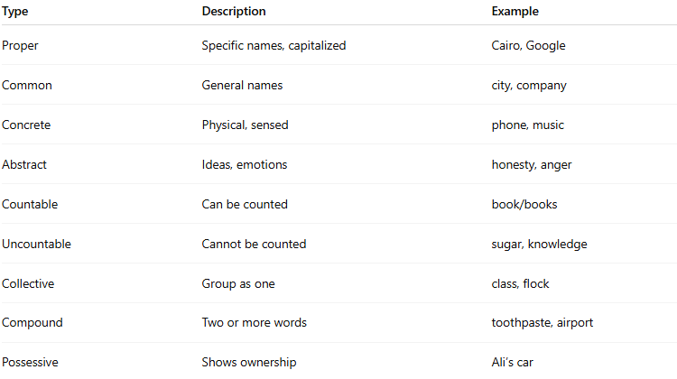

Type | Description | Example
Proper | Specific names, capitalized | Cairo, Google
Common | General names | city, company
Concrete | Physical, sensed | phone, music
Abstract | Ideas, emotions | honesty, anger
Countable | Can be counted | book/books
Uncountable | Cannot be counted | sugar, knowledge
Collective | Group as one | class, flock
Compound | Two or more words | toothpaste, airport
Possessive | Shows ownership | Ali’s car

